**Group Project Documentation   
Basic Cross-Platform Application Programming with .NET**

***FURNITURE SHOP***

**Prepared by MAQGroup**

***SE150114 Vo Duc Minh***

***SE150515 Le Hong Anh***

***SE150129 Tran Quang Quyen***

**Ho Chi Minh City, 2022**

**Table of Contents**

**Table of Contents…………………………………………………………………….... 1**

**Revision History………………………………………………………………………. 2**

**1.** **Project Introduction………………………………………………………………. 2**

1.1 Purpose**…………………………………………………………………………** 2

1.2 Overview**……………………………………………………………………….** 2

**2.** **Database Design………………………………………………………………….... 2**

**……………………………………………………………………………………… 3**

**3.** **System Architecture………………………………………………………………. 3**

**……………………………………………………………………………………... 4**

**4. Requirements……………………………………………………………………… 4**

1.1 Functional Requirements**……………………………………………………….** 4

1.2 Non-Functional Requirements**………………………………………………….** 4

**………………………………………………………………………………….** 5

**5.** **User………………………………………………………………………………… 5**

5.1 User classes and Characteristics**……………………………………………….** 5

**………………………………………………………………………………… 6**

5.2 User Workflow Diagram**………………………………………………………** 6

**………………………………………………………………………………...** 7

**………………………………………………………………………………...** 8

5.3 User Permissions**………………………………………………………………** 8

**………………………………………………………………………………...** 9

**6.** **References………………………………………………………………………... 9**

**Revision History**

| **Name** | **Date** | **Reason For Changes** |
| --- | --- | --- |
| *Database* | *01 March 2022* | *Build Web App Database* |
| *Base* | *01 March 2022* | *Build Web App Base* |
| *Code* | *01-18 March 2022* | *Coding Web App Function* |
| *Docs* | *15-18 March 2022* | *Write Docs For Web App* |

# 

# **Project Introduction**

## **Purpose**

*App was created to bring convenience to customers when shopping, giving customers a new, optimal, easy-to-see and easy-to-use experience. Provide full features related to customers and shopping in the most convenient way.*

*Targeting all customers who are in need of online shopping.*

## **Overview**

*Gave the purpose, users, project scope, technology and references. Next sections will dive deeper into the project.*

# **Database Design**

*Screenshot of Web App Database.*

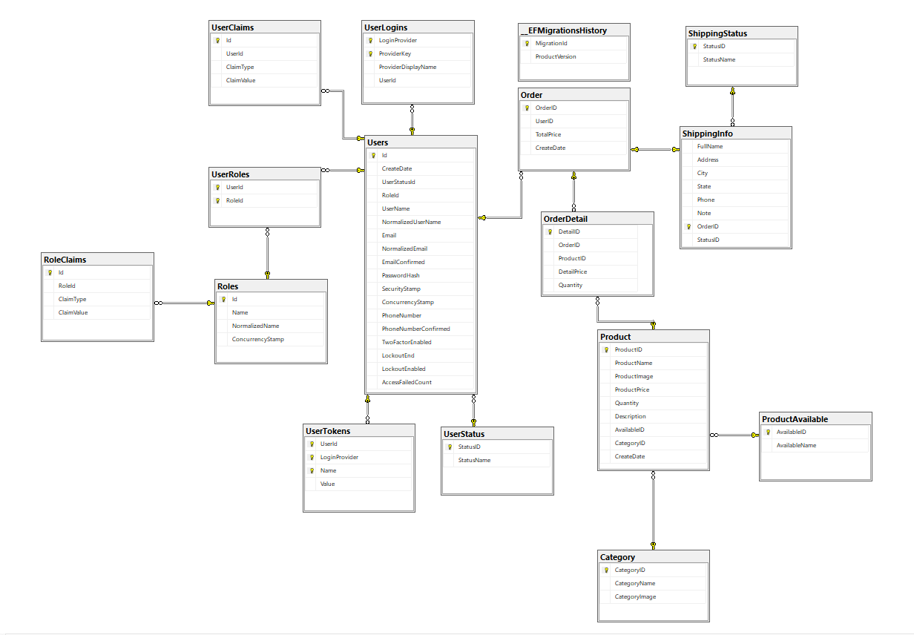

# **System Architecture**

*Back-end :*

* *Program is written with C# Programming Language.*
* *Using ASP.NET Core MVC 5.0 and Entity Framework Core.*

*Front-end :*

* *HTML*
* *CSS*
* *JavaScript*
* *Bootstrap*

*Database:*

* *Microsoft SQL Server*

*Libraries & Packages:*

* *MailKit*
* *MimeKit*
* *Newtonsoft.Json*
* *System.Data.SqlClient*
* *Microsoft.AspNetCore.Identity.Entity*
* *Microsoft.AspNetCore.Authentication*
* *Microsoft.EntityFrameworkCore*
* *Microsoft.EntityFrameworkCore.SqlServer*
* *Microsoft.Extensions.Logging.Console*
* *Microsoft.Extensions.DependencyInjection*
* *Microsoft.VisualStudio.Web.CodeGeneration.Design*

# **Requirement**

## **Functional Requirement**

*Guests :*

* *View Index Page, Login Page, Product Page, View Order Page.*
* *Add furniture to Cart but need Login to Checkout.*
* *View Order if they have Order Code and Phone Number.*
* *Register.*

*User :*

* *View Index Page, Login Page, Product Page, View Order Page, Account Details.*
* *Login and Logout.*
* *View product.*
* *Add product to cart and checkout.*
* *View history order.*
* *View and edit profile.*

*Admin :*

* *View Index Page, Login Page, Admin Manage Page..*
* *Manage user, account, product, category, order.*

## **Non-Functional Requirement**

*Guests :*

* *The guests must have the authority to use the app as the functionality stated in the Functional requirements.*
* *The interface must be pleasing to the eye, easy to see and easy to use.*
* *Guests' interactions must have a stable response, with a delay that is allowed but not too large.*

*User:*

* *The user must have the authority to use the app as the functionality stated in the Functional requirements.*
* *The interface must be pleasing to the eye, easy to see and easy to use.*
* *Registered for an account, logged in and logged out. All User information must be kept secure.*
* *User interactions must have a stable response, with a delay that is allowed but not too large.*
* *To use the services that the web provides.*

*Admin:*

* *View management pages within the data allowed to ensure security.*
* *Any data changes must ensure the reliability and integrity of the data at the highest level, avoiding data loss.*

# **User**

## **5.1 User classes and Characteristics**

*Classes :*

* *Guests*
* *User*
* *Admin*

*Characteristics:*

* *Guests: This is a temporary group of users who can view all screens of the website except adding products to cart and checkout.*

*They can sign up to become a member.*

*They can Add furniture to Cart but need Login to Checkout.*

*They can view their Order if they have Order Code and Phone Number..*

* *User: This is a group of registered users as members. They can view the screens of the website, can add products to cart and checkout, track purchase orders, and can change personal information.*

* *Admin: This is the admin group. They can perform CRUD operations with product groups, categories, users, accounts.*

## **5.2 User Workflow Diagram**

*Guests :*

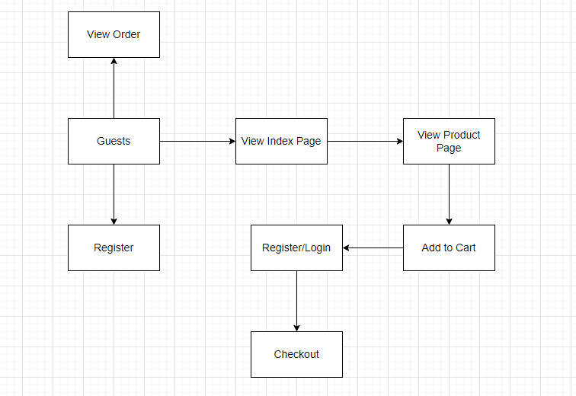

* *Guests can view Index Page, Product Page and View Order Page.*
* *Guests can Add to Cart but need to Login to CheckOut.*
* *Guests can Register to become a Website member.*
* *Guests can check their Order if they have Order Code and Phone Number..*

*User :*

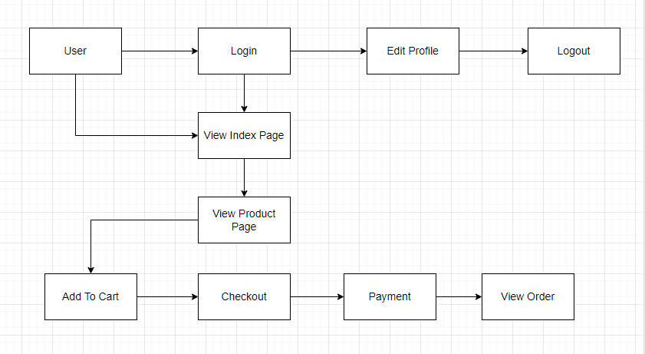

* *Users can Login to Website, View Index Page and Product Page.*
* *Users can Add product to Cart and Checkout, view History Order.*
* *Users can Edit their Profile.*
* *Users can check their Order if they have Order Code.*

*Admin:*

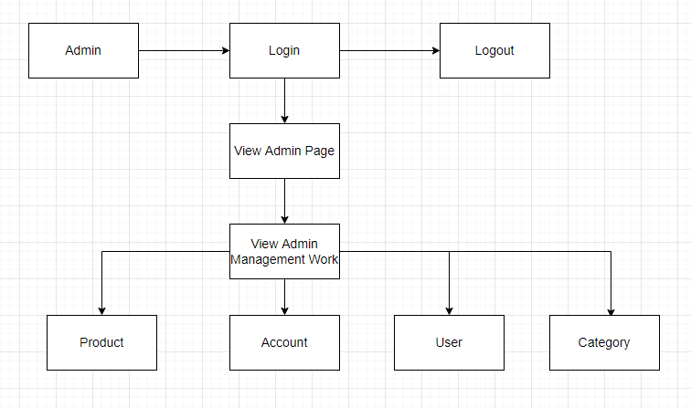

* *Admin can Login and View Admin Page.*
* *Admin can manage Website components such as: Product, Account, User, Category.*

## **5.3 User Permissions**

*Guests :*

* *Enable to View Index page.*
* *Enable to View Product page.*
* *Enable to Add furniture to Cart but need Login to Checkout.*
* *Enable to View Order page if they have Order Code and Phone Number.*
* *Enable to Register.*

*User :*

* *Enable to View Order page if they have Order code.*
* *Enable to Login, Logout.*
* *Enable to Edit Profile.*
* *Enable to View Index page.*
* *Enable to View Product page.*
* *Enable to Add Product to Cart.*
* *Enable to Checkout.*
* *Enable to View Order.*

*Admin :*

* *Enable to Login, Logout.*
* *Enable to View Admin Page.*
* *Enable to Manage Web Components.*

# **References**

1. [*ASP.NET documentation | Microsoft Docs*](https://docs.microsoft.com/en-us/aspnet/core) *to to approach and use the methods in the project.*
2. [*Stack Overflow*](https://stackoverflow.com/) *to find and fix errors, bugs from coding web app functions.*